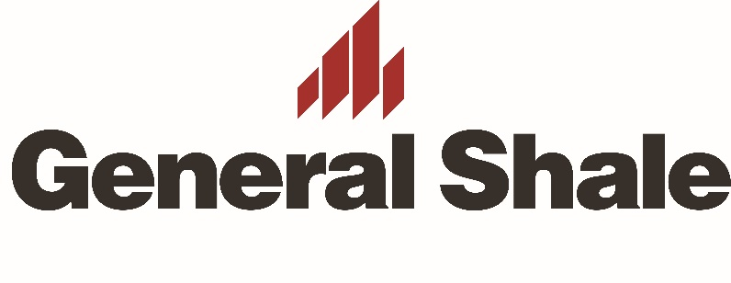

FOR IMMEDIATE RELEASE: Contact Information: Dawn Henning
November 16, 2016 800-414-4661, dawn.henning@generalshale.com

General Shale’s Kernersville Location
Wins Fifth Consecutive Gold Safety Award

KERNERSVILLE, N.C. — For the fifth consecutive year, General Shale, a longtime provider of brick for high-quality commercial and residential projects throughout the nation, has received the North Carolina Department of Labor’s Annual Gold Safety Award for its Kernersville retail location.

The North Carolina Department of Labor presented the award, which recognizes outstanding health and safety efforts during 2015, to General Shale’s retail sales center located at 1060-A Highway 66 South. The Gold Award is the top annual safety award issued by North Carolina’s Department of Labor.

Headquartered in Johnson City, Tennessee, General Shale is the North American subsidiary of Wienerberger AG and a leading manufacturer of brick, one of the world’s oldest green building materials.

“Safety is more than a priority for our company — it is a core value,” says Charles Smith, president and CEO of General Shale. “Our North Carolina teams have a history of achieving these top levels of excellence, and I am proud of their dedication to maintaining a safe environment.”

The North Carolina Department of Labor’s Safety Awards Program recognizes private and public firms throughout the state that achieve and maintain good health and safety records. To qualify for a safety award, a company must have had no fatalities during the calendar year at the location for which the award was given, and must have maintained an incidence rate that is at least 50 percent below the average for its particular industry group.

“At General Shale, we are committed to continually assessing and improving our safety procedures,” says Brian Ogle, safety and risk manager for General Shale. “We are honored to be recognized for our efforts in ensuring the well-being of our employees and remain committed to maintaining healthier, safer workplaces.”

ABOUT GENERAL SHALE
General Shale is one of North America’s largest brick, stone and concrete block manufacturers, supplying a wide variety of masonry materials for residential, commercial and specialty architectural projects. These materials include brick, thin veneers, stone, outdoor living kits, concrete block and various building materials, which include Arriscraft® Stone Products. The company offers an endless array of sizes, colors and textures to complete any building project. With a life cycle of more than 100 years, the sustainability of brick is the company’s commitment to responsible stewardship.

Throughout the U.S. and Canada, General Shale operates manufacturing facilities in nine states and provinces, in addition to a network of more than 40 retail showrooms and over 300 affiliated distributors across North America. In 1999, General Shale grew even stronger when it joined Wienerberger AG of Vienna, Austria, the world’s largest brick manufacturer.

General Shale was founded in 1928 and is headquartered in Johnson City, Tennessee. For more information, visit www.generalshale.com.

– ### –

